



FUNDAMENTALS OF
WEB DESIGN
(405)

NATIONAL 2021

Production:
Multiple Choice (20 @ 10 points each) __________ (100 points)
Application __________ (355 points)

TOTAL POINTS __________ (455 points)

Test Time: 60 minutes

MULTIPLE CHOICE:

- A
- A
- D
- D
- C
- A
- D
- B
- A
- C
- D
- A
- D
- B
- D
- C
- B
- D
- D
- C

HTML ANSWER KEY
<!DOCTYPE html>
<html lang="en">

<head>
<title>Constant number - Fundamentals of Web Design</title>
<link href="stylesheets3.css" type="text/css" rel="stylesheet">
<!--Write a comment in the section-->
</head>

<body>
<div id="container">
<img src="russoslogo.png" alt="Russo Pizza Logo">

<nav>
<a href="index.html">Home</a> |
<a href="menu.html">Menu</a> |
<a href="order.html">Order</a>
</nav>

<hr>

<section>
<h1>CUSTOMER INFORMATION</h1>
<p>Thank you for using our online ordering form for quick and easy
orders. Please enter your name and phone number and whether you
want to place an order for delivery or pickup. Note that required
values are marked by an asterisk (*). If you
want to place your order over the phone, call us at
<a href="tel:+16145551234">(614) 555-1234</a>.</p>

<form action=https://www.example.com/russopizzas/customer method="post">

<div>
<label for="nameBox">Name*</label>
<input name="custName" id="nameBox" type="text" placeholder="First and Last Name" required>
</div>

<div>
<label for="phoneBox">Phone*</label>
<input name="custPhone" id="phoneBox" type="tel" required placeholder="(nnn) nnn-nnnn" pattern="^\d{10}$|^(\(\d{3}\)\s*)?\d{3}[\s-]?\d{4}$">
</div>

<div>
<input name="orderType" id="delivery" type="radio"
checked><label for="delivery">Delivery</label>
<input name="orderType" id="pickup" type="radio"><label
for="pickup">Pickup</label>
</div>

<fieldset id="deliveryInfo">
<legend>Delivery Options</legend>
<textarea name="delAddress" id="addressBox"
placeholder="Enter delivery address"></textarea>
<div>
<label for="delBox">Delivery Time (leave blank for
earliest delivery)</label>
<input name="delTime" id="delBox" type="time">
</div>

</fieldset>

<fieldset id="pickupInfo">
<legend>Pickup Options</legend>
<label for="pickupBox">Pickup Time (leave blank for earliest
pickup)</label>
<input name="pickupTime" id="pickupBox" type="time">
</fieldset>

<div>
<input type="submit" value="Begin Building your Order">
</div>
</form>
</section>
<hr>

<p>&copy; 2019 Russo's Pizzeria. All rights reserved.</p>
</div>
</body>
</html>

CSS ANSWER KEY:

/* Form Styles */
form {
display: -webkit-flex;
display: flex;
-webkit-flex-flow: row wrap;
flex-flow: row wrap;
}

fieldset {
background-color: rgb(234, 189, 142);
-webkit-flex: 1 1 300px;
flex: 1 1 300px;
margin: 10px;
}

div {
margin: 5px;
width: 100%;
}

legend {
color: rgb(255, 200, 200);
background-color: rgb(179, 20, 25);
}

label {
display: inline-block;
width: 120px;
}

fieldset#pickupInfo label,
fieldset#deliveryInfo label {
margin-bottom: 10px;
width: 100%;
}

body {
background-color: rgb(128, 0, 0);
color: #000000;
font-family: 'Times New Roman', Times, sans-serif;
}

#container {
background-color: #FFFFFF;
width: 80%;
margin: 0 auto;
padding: 25px;
}

img {
display: block;
width: 40%;
margin-left: auto;
margin-right: auto;
}

nav {
text-align: center;
}

a:link {
color: black;
}

a:hover {
color: white;
background-color: red;
}

Sample:

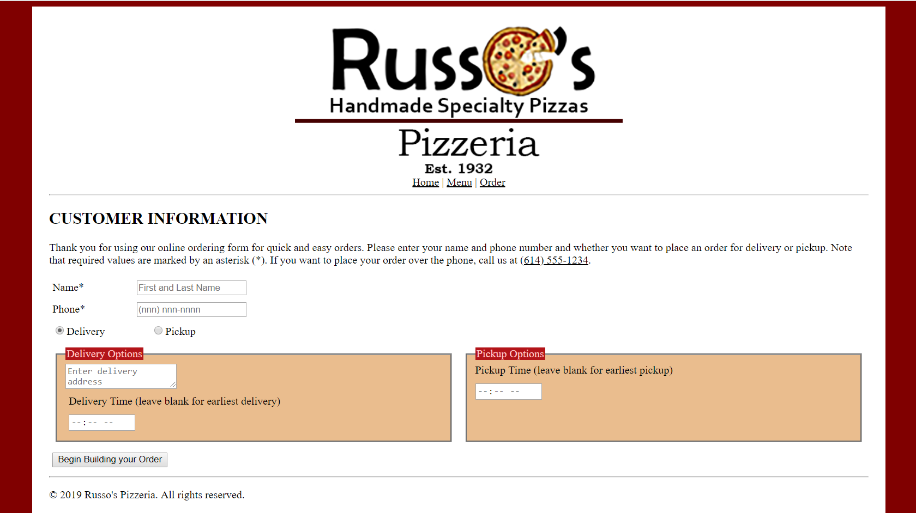

CSS KEY

body{
background-image: url(Pictures/gold.jpg)
}
#box{
background-color:gray;
width: 900px;
margin: auto;
border: solid;
border-color: black;
border-width: 5px;
padding-left: 20px;
}
.headA{
color: #DCCC40;
text-decoration: underline;
text-align: center;
}
span{
color: #DCCC40;
text-decoration: underline;
}
.image{
float: right;
border: thin black solid;
margin-right: 20px;
}
.list{
list-style-image:url(Pictures/letter.jpg);
color: #DCCC40;
margin-left: 20px;
font-size: 16pt;
}
nav {
text-align: center;
}

APPLICATION RUBRIC

HTML | Point Value | Score
Correct DOCTYPE declaration | 5
Set document to <meta charset=”UTF-8”> | 5
<head> tag properly placed and used | 5
<nav> tag and create a navigation bar | 10
<title> tag includes contestants BPA membership number | 10
<link> tag reference to a CSS stylesheet | 10
<body> tag has no attributes | 5
Place A-Ship Photo with correct alternative name “A-Ship_Logo” | 5
Spans were placed around “largest” and “$99” | 10
Had the correct headings for each title | 20
Have all the text for the paragraph in <p> tags with no mistakes or misspellings - 5 points taken off for misspellings | 15
Correct coding for bulleted list | 15
The Navigation bar at the top included hyperlinks to the correct websites | 15
HTML TOTAL | 130

CSS | Point Value | Score
Style Sheet is external: (Can be called anything) | 10
body { background-image: url(Pictures/gold.jpg) | 5
#box{ was style as the following:  background-color:gray;  width: 900px;  margin: auto;  border: solid;  border-color: black;  border-width: 5px;  padding-left: 20px; | 5  5  5  5  5  5  5
.headA{ was style as the following:  color: #DCCC40;  text-decoration: underline;  text-align: center; | 5  5  5
Span{ was style as the following:  color: #DCCC40;  text-decoration: underline; | 5  5
.image{ was style as the following:  float: right;  border: thin black solid;  margin-right: 20px; | 5  5  5
.list{ was style as the following:  list-style-image:url(Pictures/letter.jpg);  color: #DCCC40;  margin-left: 20px;  font-size: 16pt; | 5  5  5  5
.nav{ was style as the following:  text-align: center; | 5
CSS TOTAL | 115
FORMATTING | Point value | Score
Deduct 5 points for each discrepancy, up to 15 points | 15
Application Total | 245
Objective Total (from page 2)
EVENT TOTAL

